

**APAMAN**

**Software Design Specification**

– Hanoi, February 2023 –

**Record of changeS**

| **Date** | **A* M, D** | **In charge** | **Change Description** |
| --- | --- | --- | --- |
|  |  |  |  |
|  |  |  |  |
|  |  |  |  |
|  |  |  |  |
|  |  |  |  |
|  |  |  |  |
|  |  |  |  |
|  |  |  |  |
|  |  |  |  |
|  |  |  |  |
|  |  |  |  |
|  |  |  |  |
|  |  |  |  |

*A - Added M - Modified D - Deleted

**Table of Contents**

I. Overview 4

1. Code Packages 4

2. Database Design 4

a. Database Schema 4

b. Table Description 4

II. Code Designs 5

1. <Feature/Function Name1> 5

a. Class Diagram 5

b. Class Specifications 5

c. Sequence Diagram(s) 5

d. Database queries 6

2. <Feature/Function Name2> 6

# I. Overview

## 1. Code Packages

### 1.1 Back-end Package Diagram

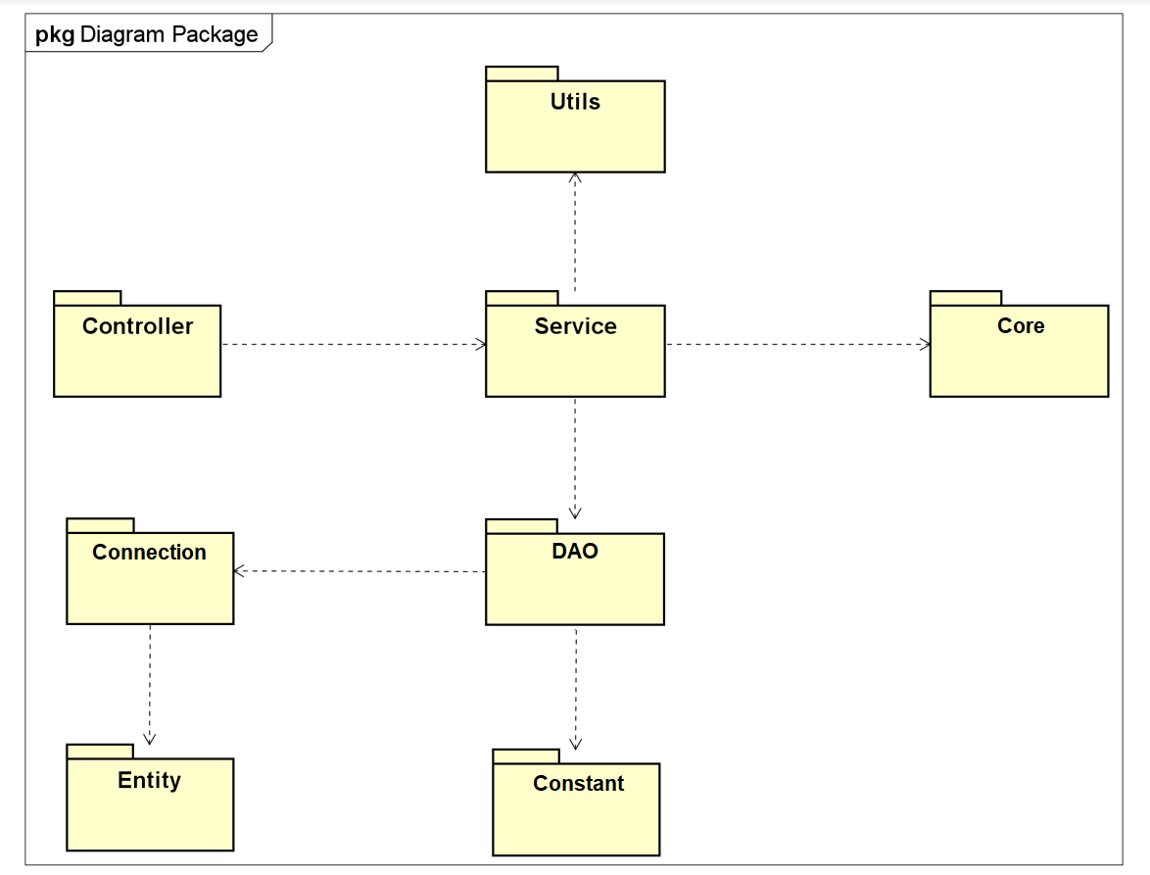

***Package descriptions***

| **No** | **Package** | **Description** |
| --- | --- | --- |
| 01 | DAO | Contains interfaces which communicate with the database. |
| 02 | controller | Contains classes which handle incoming requests. |
| 03 | service | Contains classes which are used to perform business logic. These classes communicate with data tier, process data then return to controller classes. |
| 04 | entity | Contains classes represent real entities which can be persisted in the database and some additional helper classes. |
| 05 | utils | Contains validation, formatter classes. |
| 06 | core | Contains filter layer classes. |
| 07 | constant | Contain constant value |
| 08 | connection | Contain classes which help connecting to database |

### 1.2 Front-end Package Diagram

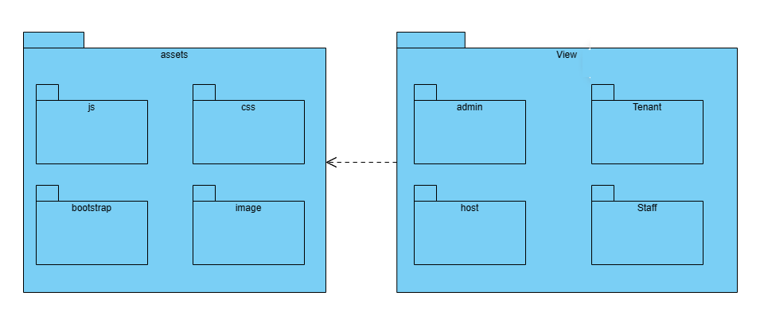

| **No** | **Package** | **Description** |
| --- | --- | --- |
| 01 | assets | Package contains all resource file in front-end |
| 02 | js | Package contains all java script files which is not available in bootstrap |
| 03 | css | Package contains all css files which is not available in bootstrap |
| 04 | image | Package contains all images and icons appeared on website |
| 05 | views | Package contains all jsp files which include all-role webpages |
| 06 | admin | Package contains all admin jsp file |
| 07 | tenant | Package contains all tenant jsp file |
| 08 | host | Package contains all host jsp file |
| 09 | staff | Package contains all staff jsp file |

## 2. Database Design

### a. Database Schema

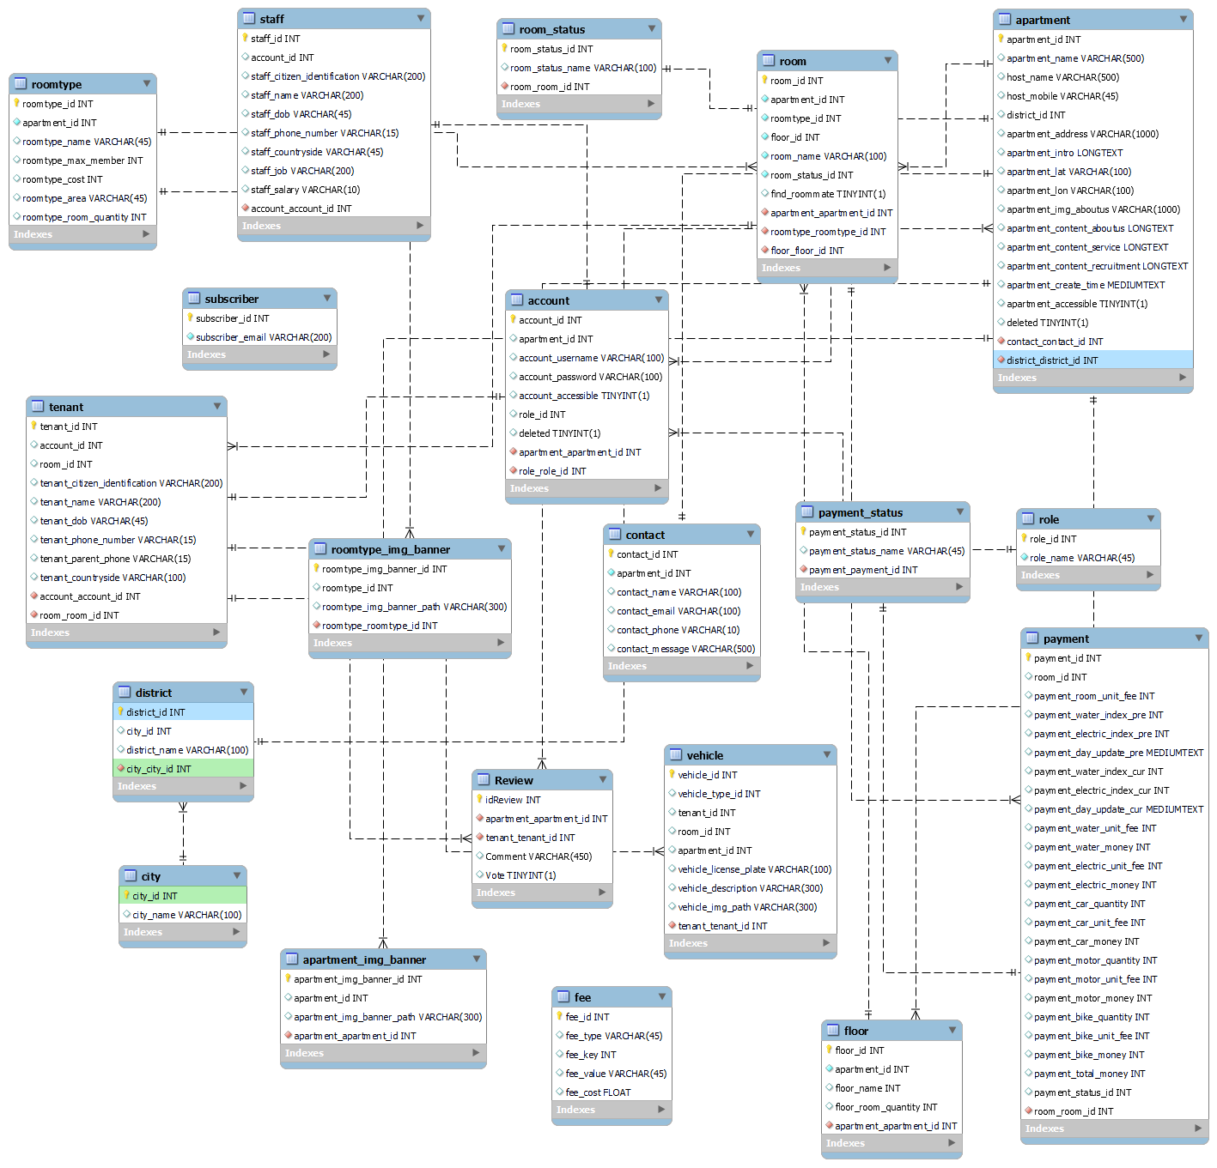

### b. Table Description

#### 1.Account

| **No** | **Table** | **Description** |
| --- | --- | --- |
| 01 | Account | account_id : **Int** (NOT NULL , AUTO_INCREMENT)  apartment_id : **Int**  account_username : **Varchar**  account_password : **Varchar**  account_accesible : **tinyint**  role_id : **int**  deleted t: **tinyint**  PRIMARY_KEY : **account_id**  FOREIGN KEY **: apartment_apartment_id , apartment_account_account_id , role_role_id** |

#### 2.Apartment

| **No** | **Table** | **Description** |
| --- | --- | --- |
| 02 | Apartment | apartment_id : **Int** (NOT NULL , AUTO_INCREMENT)  apartment_name : **Varchar**  host_name : **Varchar**  host_mobile : **Varchar**  district_id : **Int**  apartment_address : **Varchar**  apartment_intro : **longtext**  apartment_latitude : **Varchar**  apartment_longtitude : **Varchar**  apartment_img_aboutus : **Varchar**  apartment_content_aboutus : **longtext**  apartment_content_service: **longtext**  apartment_content_recruitment : **longtext**  apartment_accessible : **tinyint**  account_account_id : **INT**  delete : **TINYINT**  PRIMARY_KEY **: apartment_id , account_account_id** |

#### 3. Apartment_img

| **No** | **Table** | **Description** |
| --- | --- | --- |
| 03 | Apartment_img | apartment_img_banner_id` : **Int** (NOT NULL , AUTO_INCREMENT  apartment_id` : **Int**  apartment_img_banner_path` :  **Varchar**  PRIMARY_KEY **: apartment_img_banner_id**  FOREIGN_KEY :  **apartment_apartment_id** |

#### 

#### ***4. City***

| **No** | **Table** | **Description** |
| --- | --- | --- |
| 04 | City | city_id : **Int** (NOT NULL , AUTO_INCREMENT  city_name :  **Varchar**  PRIMARY_KEY **: city_id**  FOREIGN_KEY :  **apartment_apartment_id , apartment_account_account_id** |

#### 5.District

| **No** | **Table** | **Description** |
| --- | --- | --- |
| 05 | City | district_id : **Int** (NOT NULL , AUTO_INCREMENT)  city_id : **Int**  district_name :  **Varchar**  PRIMARY_KEY **: district_id**  FOREIGN_KEY : **city_city_id** |

#### 6. Floor

| **No** | **Table** | **Description** |
| --- | --- | --- |
| 06 | Floor | floor_id : **Int** (NOT NULL , AUTO_INCREMENT)  apartment_id : **Int**  floor_name : **Varchar**  PRIMARY_KEY : **floor_id** |

#### 7. Role

| **No** | **Table** | **Description** |
| --- | --- | --- |
| 07 | Role | role_id : **Int (**NOT NULL , AUTO_INCREMENT**)**  role_name : Varchar  PRIMARY_KEY : **role_id** |

#### ***8. RoomType***

| **No** | **Table** | **Description** |
| --- | --- | --- |
| 08 | RoomType | roomtype_id :  **Int (**NOT NULL , AUTO_INCREMENT**)**  apartment_id :  **int**  roomtype_name :  **varchar(45)**  roomtype_max_member : **int**  roomtype_cost :  **int**  roomtype_area : **varchar**  PRIMARY KEY : **roomtype_id** |

***9. Staff***

| **No** | **Table** | **Description** |
| --- | --- | --- |
| 09 | Staff | staff_id : **int**  account_id : **int**  staff_citizen_identification : **varchar**  staff_name : **varchar**  staff_dob : **varchar**  staff_phone_number : **varchar**  staff_countryside : **varchar**  staff_job : **varchar**  staff_salary : **varchar**  PRIMARY KEY : **staff_id**  FOREIGN_KEY : **account_account_id** |

# II. Code Designs

## 1. Feature 1: Authentication and Authorization

### a. Class Diagram

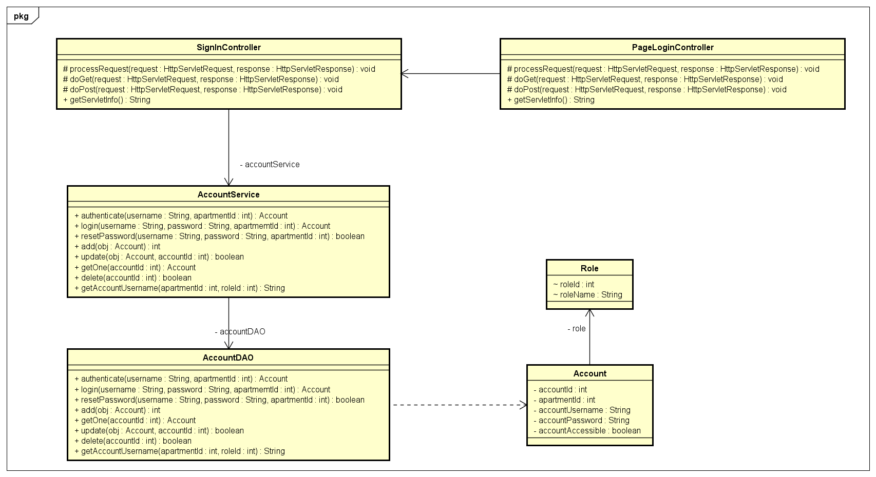

### b. Class Specifications

### c. Sequence Diagram(s)

#### Function: Login

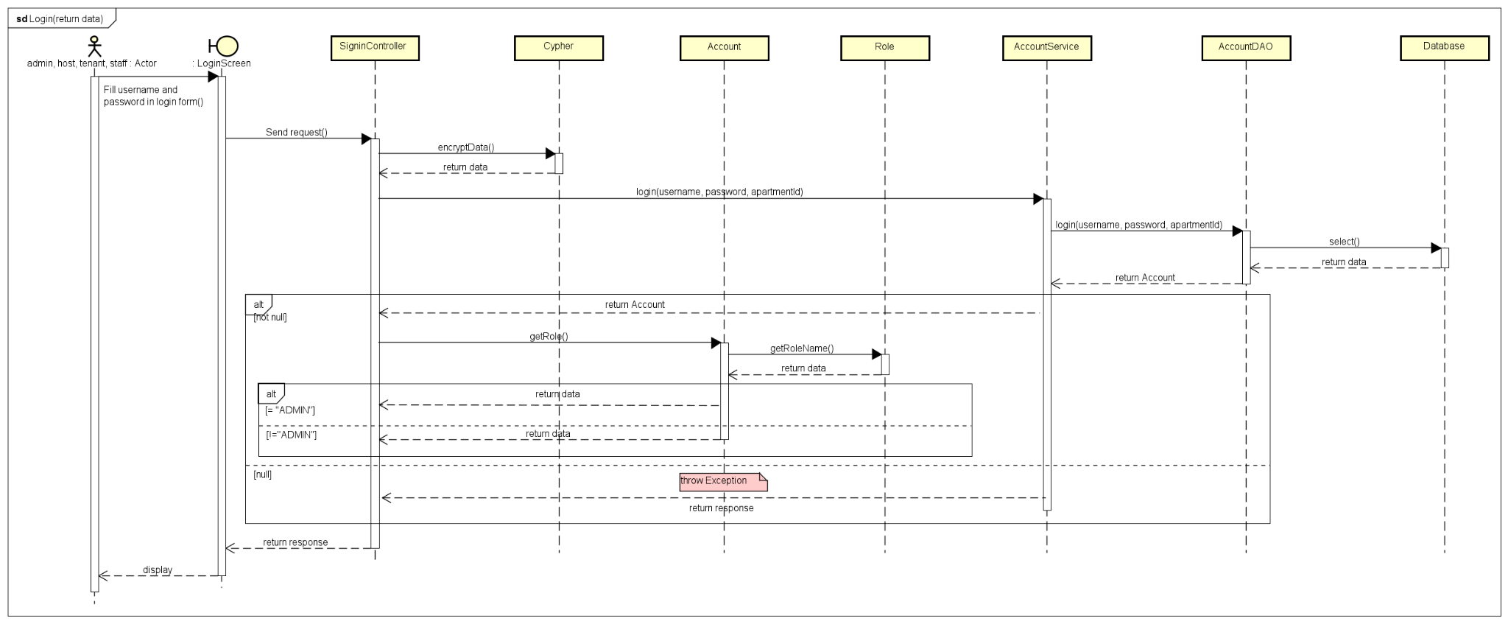

#### Function: Logout

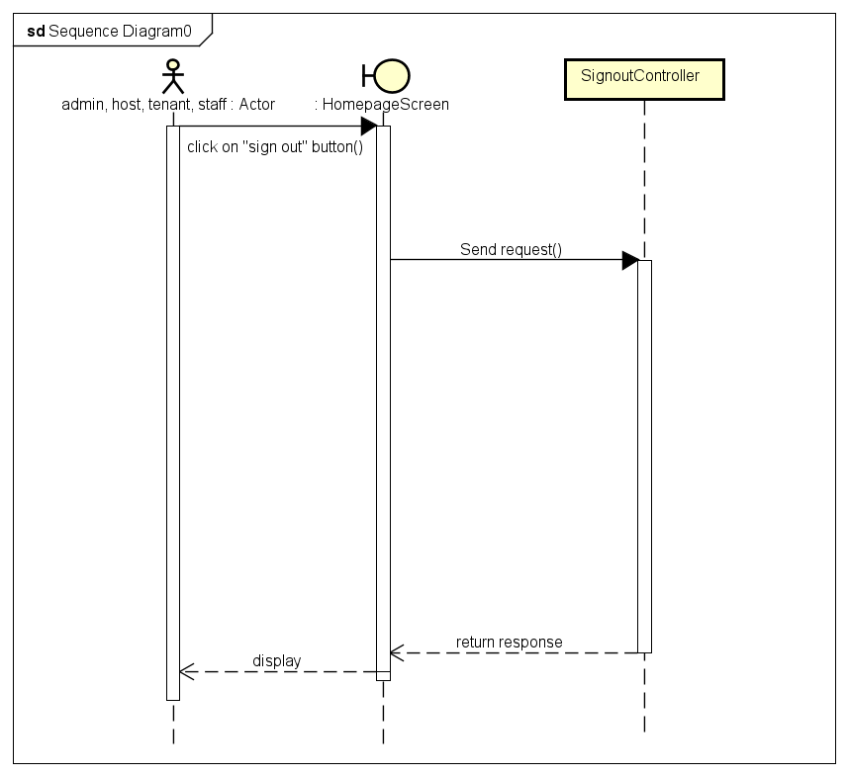

#### Function: Forgot and Reset Password

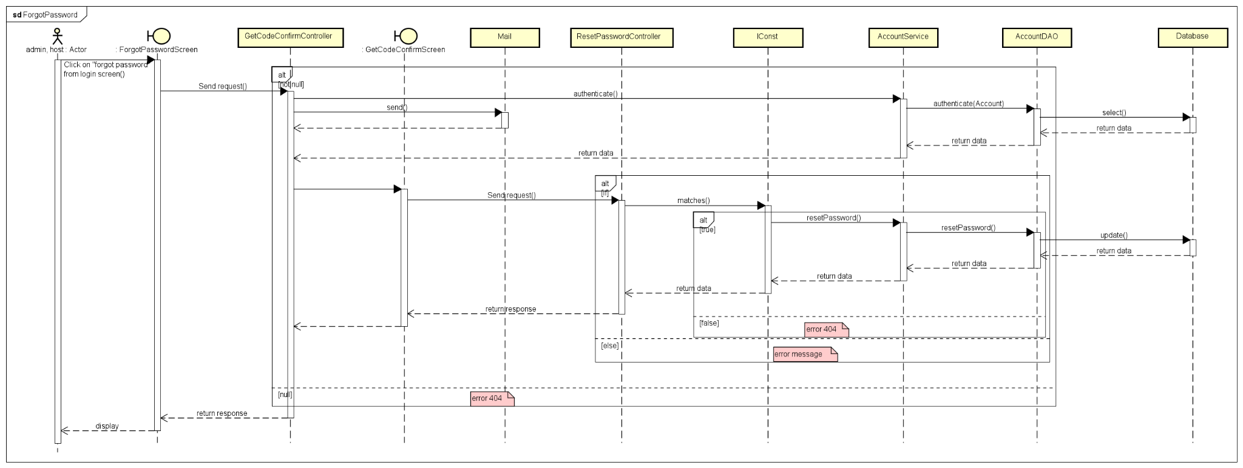

### d. Database Queries

* ***Login function queries:***

*SELECT a.account_id, a.apartment_id, a.account_username, a.account_password, r.role_name FROM apamandb.`account` a join `role` r ON a.role_id = r.role_id\n"*

*+ "Where a.account_username = ? AND a.account_password = ? AND a.account_accessible = true AND deleted = false AND (a.apartment_id = 0 OR a.apartment_id = ?)"*

## 2. Feature 2: Manage Apartment

### a. Class Diagram

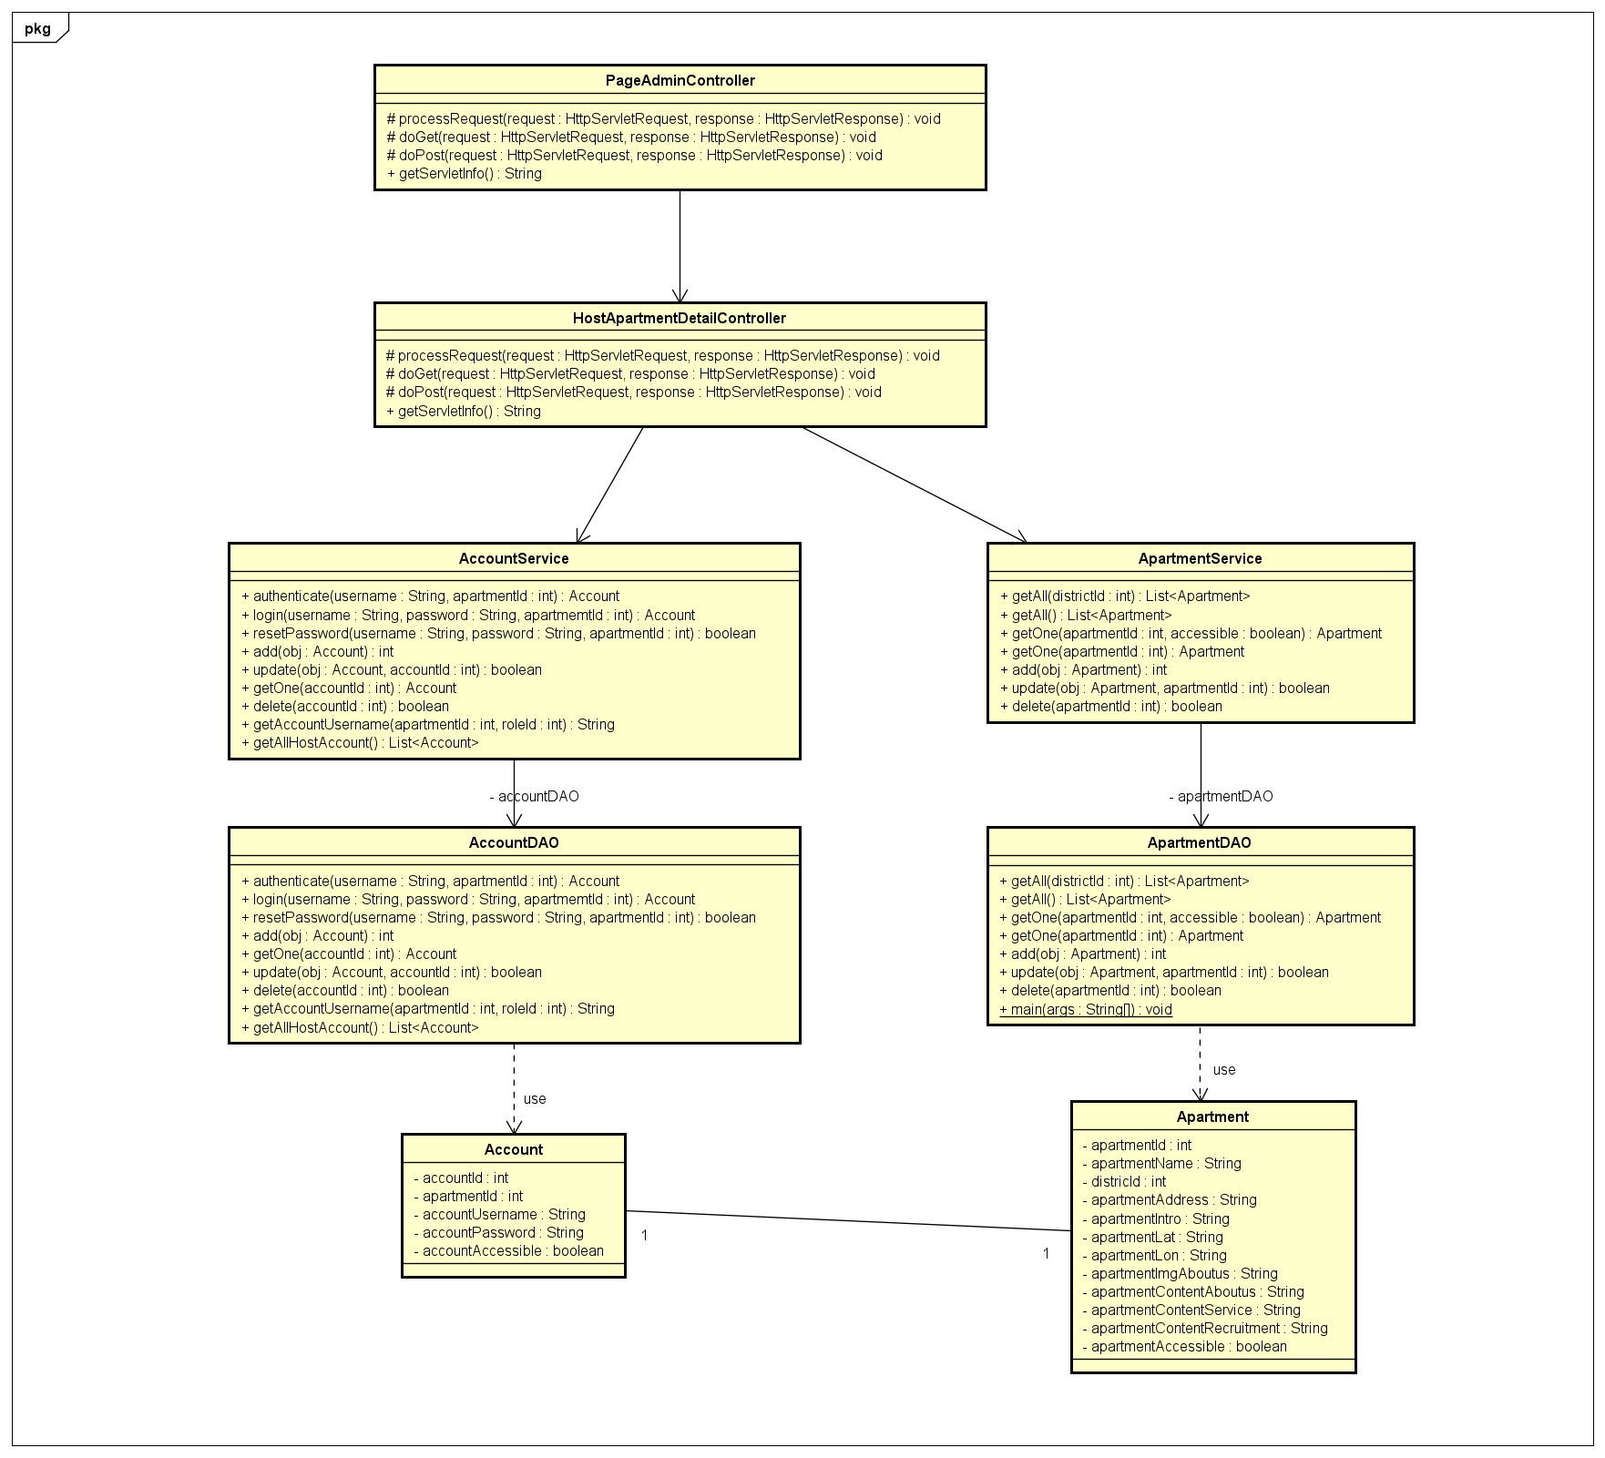

### b. Class Specifications

#### 

### c. Sequence Diagram(s)

#### Function: Create Host Account

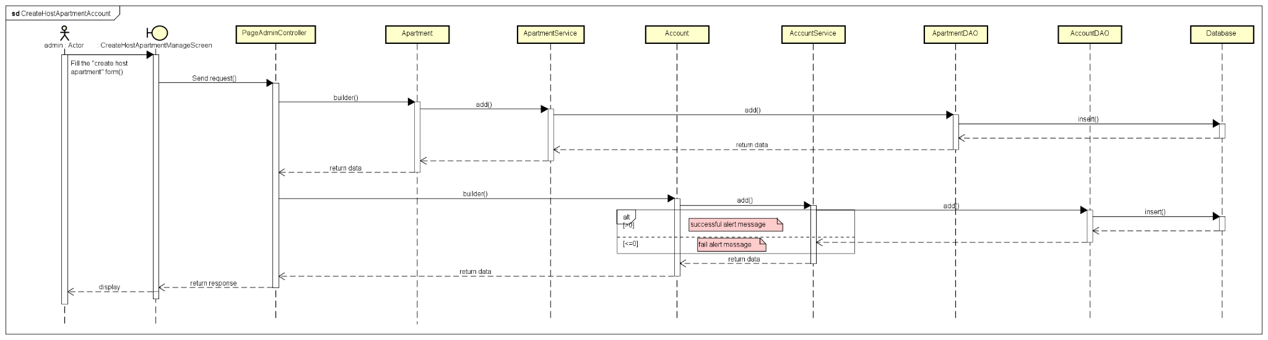

## 

#### Function: Edit Host Account

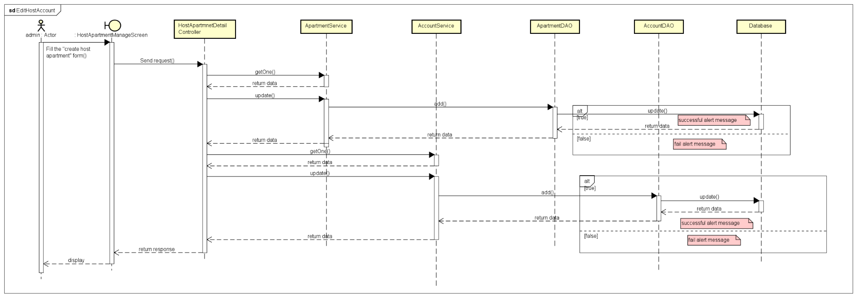

#### Function: Delete Host Account

## 

### d. Database Queries

* ***Create host account function queries:***

*"INSERT INTO `account`(apartment_id, account_username, account_password, account_accessible, role_id, deleted)" + " VALUES(?, ?, ?, ?, ?, ?)"*

* ***Edit host account function queries:***

*"UPDATE apamandb.`account` SET apartment_id = ?, account_username = ?, account_password = ?, account_accessible = ?, role_id = ? WHERE account_id = ?"*

* ***Delete host account function queries:***

*UPDATE `account` SET deleted = 1 WHERE account_id = ?*

## 3. Feature 3: Manage HomePage

### a. Class Diagram

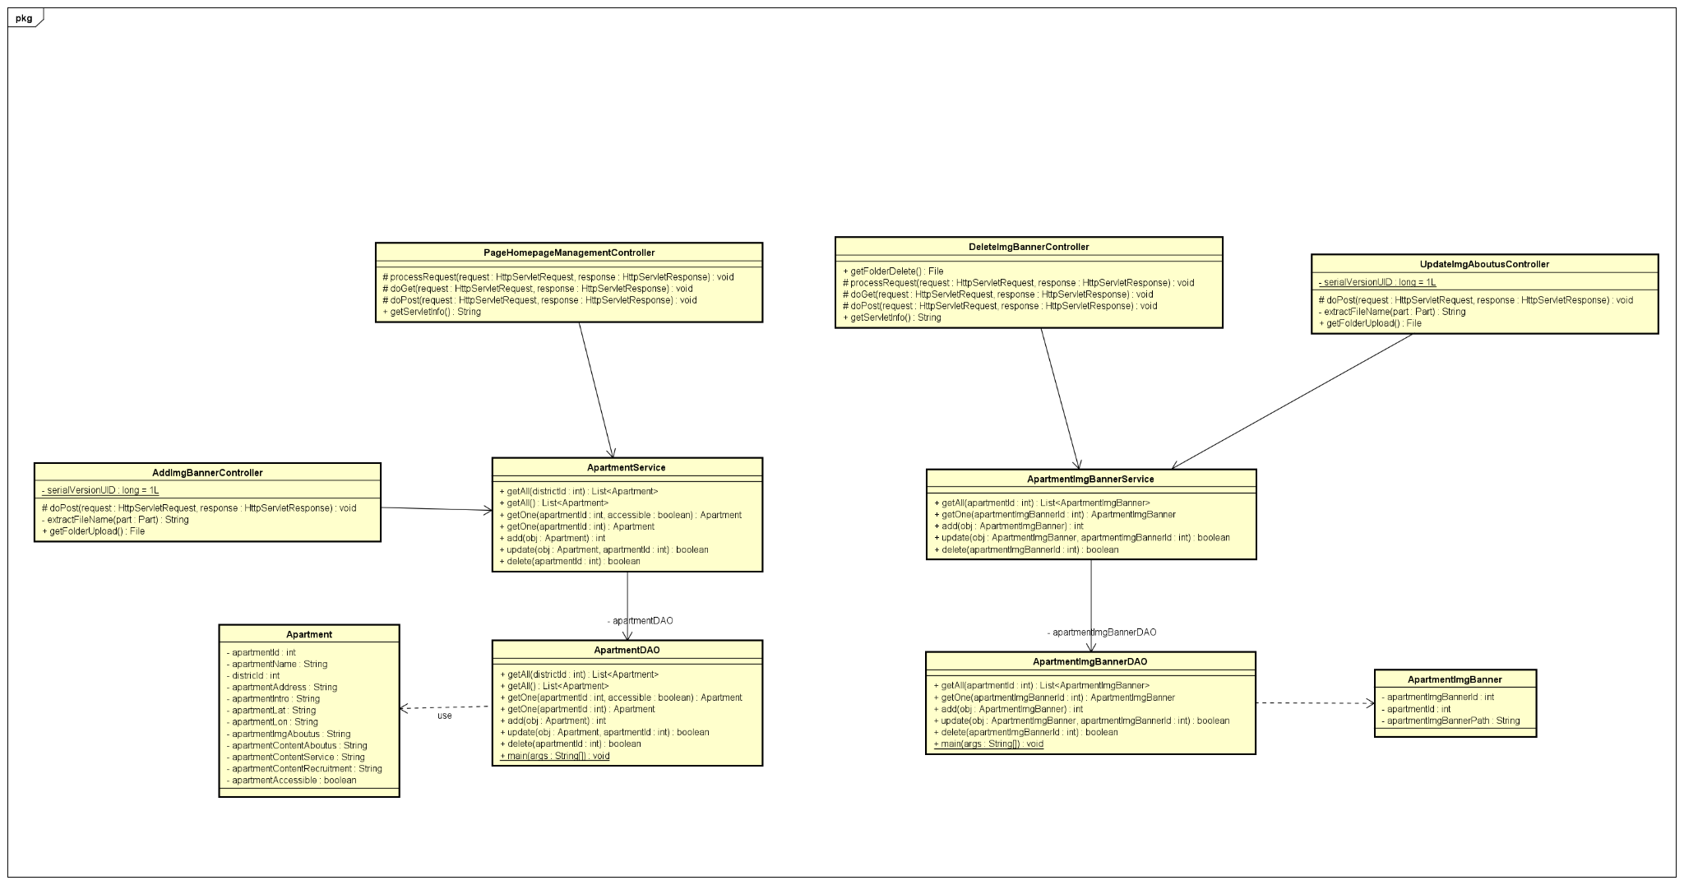

### b. Class Specifications

#### 

***Class Methods***

| **No** | **Method** | **Description** |
| --- | --- | --- |
|  |  |  |
|  |  |  |

### c. Sequence Diagram(s)

#### Function: Edit HomePage

#### 

#### Function: Add Image Banner

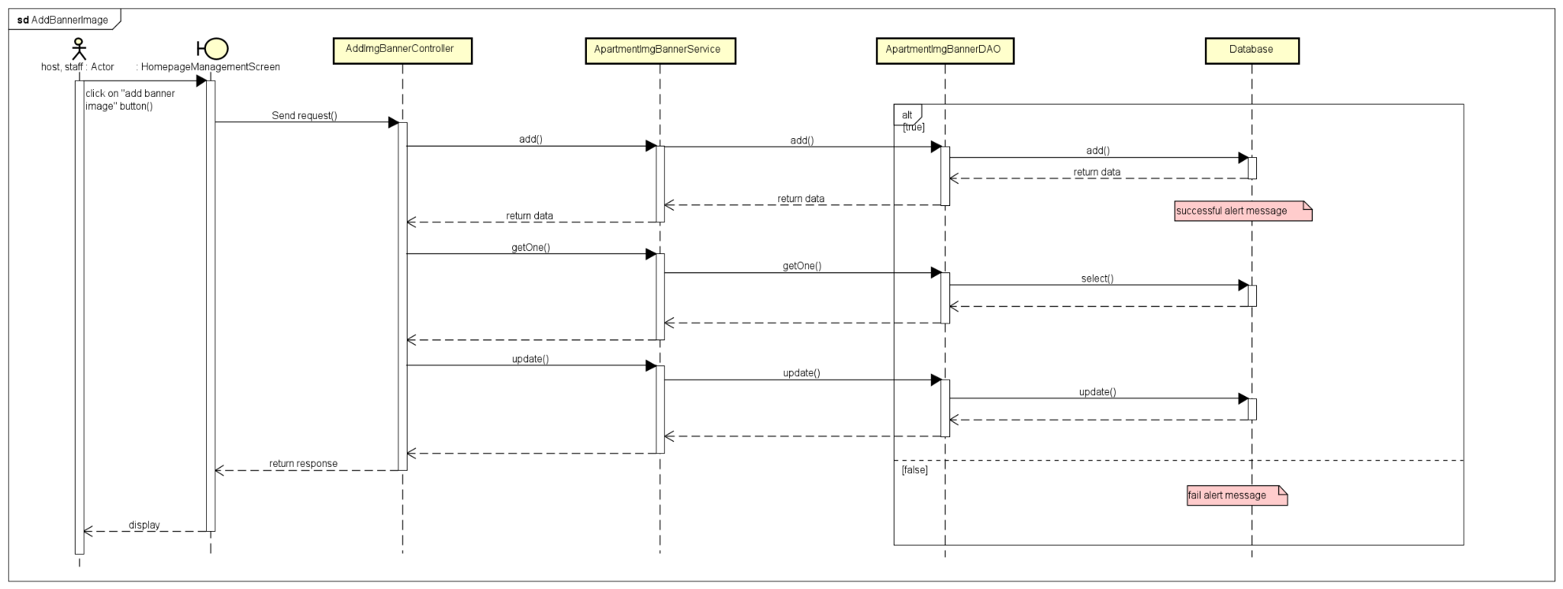

#### Function: Delete Image Banner

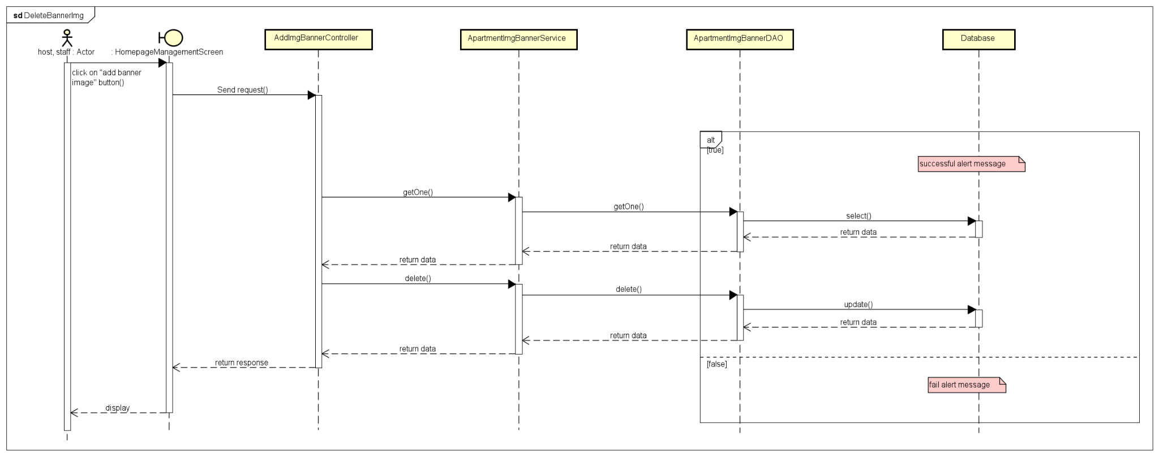

#### Function: Filter Apartment

#### 

#### Function: Subcribe

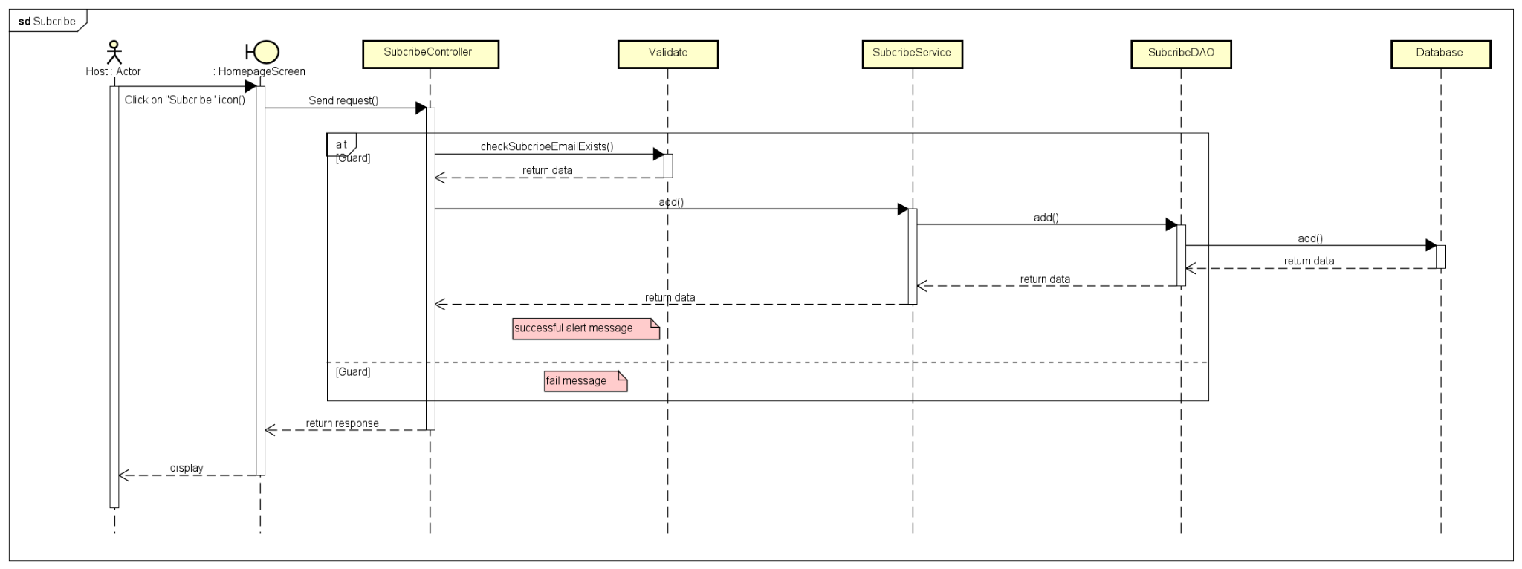

#### Function: Contact

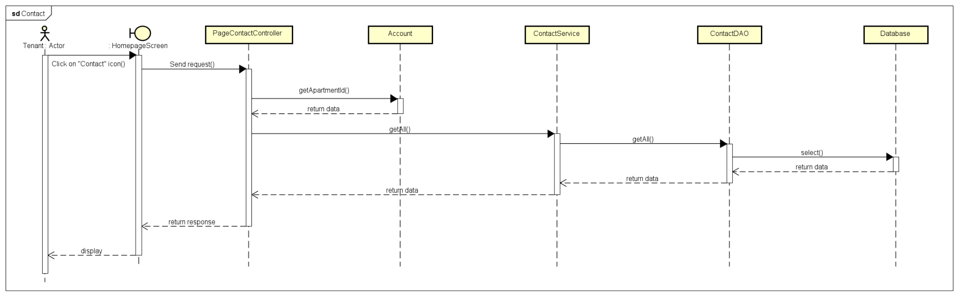

### d. Database Queries

* ***Create host account function queries:***

*"INSERT INTO `account`(apartment_id, account_username, account_password, account_accessible, role_id, deleted)" + " VALUES(?, ?, ?, ?, ?, ?)"*

* ***Edit host account function queries:***

*"UPDATE apamandb.`account` SET apartment_id = ?, account_username = ?, account_password = ?, account_accessible = ?, role_id = ? WHERE account_id = ?"*

* ***Delete host account function queries:***

*UPDATE `account` SET deleted = 1 WHERE account_id = ?*

## 4. Feature 4: Manage Staff

### a. Class Diagram

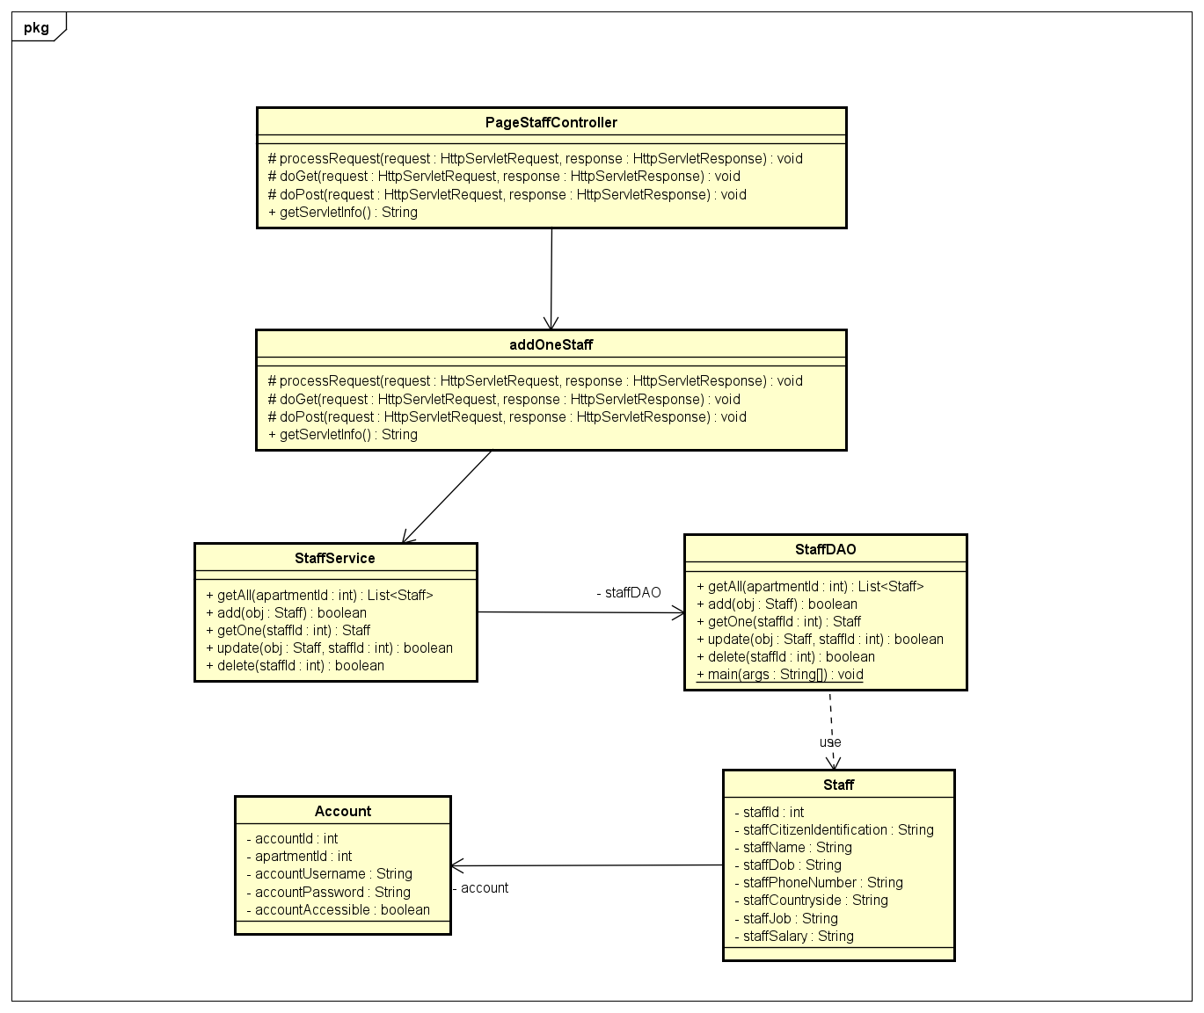

### b. Class Specifications

#### 

#### 

### c. Sequence Diagram(s)

#### Function: Add Staff

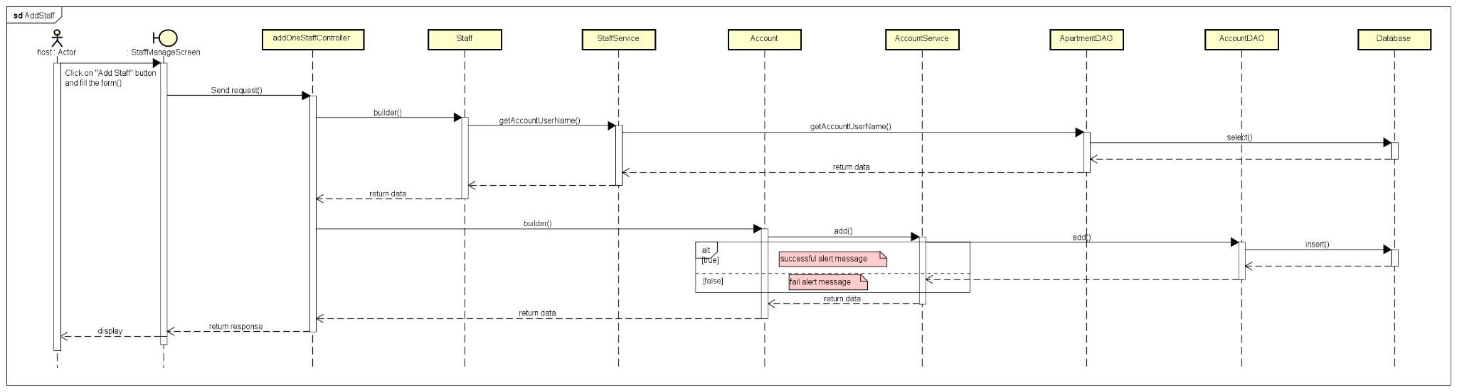

### d. Database Queries

* ***Add staff function queries:***

*"INSERT INTO staff(account_id, staff_citizen_identification, staff_name, staff_dob, staff_phone_number, staff_countryside, staff_job, staff_salary)" + " VALUES(?, ?, ?, ?, ?, ?, ?, ?)"*

## 5. Feature 5: Manage Room

### a. Class Diagram

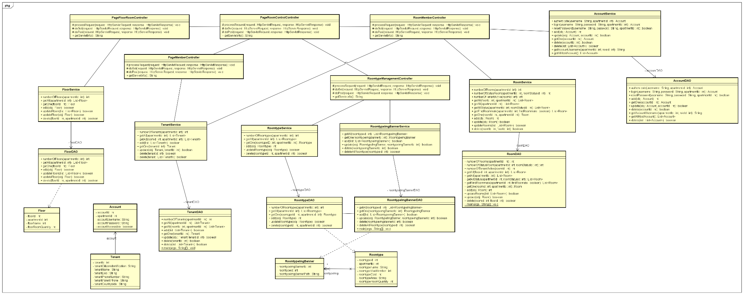

### b. Class Specifications

RoomMemberController

| No | Method | Description |
| --- | --- | --- |
| 1 | doGet | displayed all tenant information in one room |
| 2 | doPost | update and delete tenant in room |

PageMemberController

| No | Method | Description |
| --- | --- | --- |
| 1 | doGet | View tenant vehicle ** |
| 2 | doPost | N/A |

RoomTypeManagementController

| No | Method | Description |
| --- | --- | --- |
| 1 | doGet | View room type detail by apartmentID and roomtypeID |
| 2 | doPost | Update and Delete room type of apartment |

PageRoomControlController

| No | Method | Description |
| --- | --- | --- |
| 1 | processRequest | View menu control and count floor, room, room type, tenant and staff of apartment |

FloorService

| No | Method | Description |
| --- | --- | --- |
| 1 | getOne | get one floor by floor_id |
| 2 | add | add new floor into apartment |
| 3 | update | edit floor information |
| 4 | delete | delete one floor |
| 5 | getAll | get all floor by apartment_id |

TenantService

| No | Method | Description |
| --- | --- | --- |
| 1 | getOne | get one tenant information by tenant_id |
| 2 | add | add one tenant into room |
| 3 | update | edit tenant information |
| 4 | delete | delete tenant |
| 5 | getAll | get all tenant of room |

RoomTypeService

| No | Method | Description |
| --- | --- | --- |
| 1 | getOne | get one room type by roomtypeId and apartmentId |
| 2 | add | add new room type |
| 3 | update | edit room type information |
| 4 | delete | delete a room type exist in apartment |
| 5 | getAll | get all room type of apartment |

RoomTypeImgBannerService

| No | Method | Description |
| --- | --- | --- |
| 1 | getOne | get a Roomtype image banner by roomtypeImgBannerId |
| 2 | add | add room type image |
| 3 | update | edit room type image |
| 4 | delete | delete room type image |
| 5 | getAll | get all room type image of room type |

RoomService

| No | Method | Description |
| --- | --- | --- |
| 1 | getOne | get a room by roomId and apartmentId |
| 2 | add | add new room into apartment |
| 3 | update | update room information in apartment |
| 4 | delete | delete one room in apartment |
| 5 | getAll | get all room exist in apartment by apartmentId |

AccountService

| No | Method | Description |
| --- | --- | --- |
| 1 | getOne | get one account by accountId |
| 2 | add | add new account |
| 3 | update | update account exist in database |
| 4 | delete | delete account exist in database |
| 5 | getAll | get all account in database |

FloorDAO

| No | Method | Description |
| --- | --- | --- |
| 1 | getOne | get a floor by floorId |
| 2 | add | add new floor into apartment |
| 3 | update | edit floor information |
| 4 | delete | delete a floor in apartment |
| 5 | getAll | get all floor in apartment by apartmentId |

TenantDAO

| No | Method | Description |
| --- | --- | --- |
| 1 | getOne | get one Tenant by tenantId |
| 2 | add | add new tenant |
| 3 | update | edit tenant information |
| 4 | delete | delete tenant of room |
| 5 | getAll | get all tenant in room by roomId |

RoomTypeDAO

| No | Method | Description |
| --- | --- | --- |
| 1 | getOne | get a room type by roomtypeId |
| 2 | add | add new room type into apartment |
| 3 | update | edit room type information |
| 4 | delete | delete a room type |
| 5 | getAll | get all room type of apartment by apartmentId |

RoomTypeImgBannerDAO

| No | Method | Description |
| --- | --- | --- |
| 1 | getOne | get a Roomtype image banner by roomtypeImgBannerId |
| 2 | add | add new room type image banner |
| 3 | update | edit image banner of room type |
| 4 | delete | delete room type image banner |
| 5 | getAll | get all room type image banner of room type by roomtypeId |

RoomDAO

| No | Method | Description |
| --- | --- | --- |
| 1 | getOne | get a room of apartment by roomId and apartmentId |
| 2 | add | add new room into apartment |
| 3 | update | edit room information |
| 4 | delete | delete a room in apartment |
| 5 | getAll | get all room in apartment by apartmentId |

AccountDAO

| No | Method | Description |
| --- | --- | --- |
| 1 | getOne | get one account by accountId |
| 2 | add | add new account |
| 3 | update | update account exist in database |
| 4 | delete | delete account exist in database |
| 5 | getAll | get all account in database |

Floor

| No | Method | Description |
| --- | --- | --- |
| 1 | getOne | get a floor by floorId |
| 2 | add | add new floor into apartment |
| 3 | update | edit floor information |
| 4 | delete | delete a floor in apartment |
| 5 | getAll | get all floor in apartment by apartmentId |

#### 

### c. Sequence Diagram(s)

#### Function: Add Room

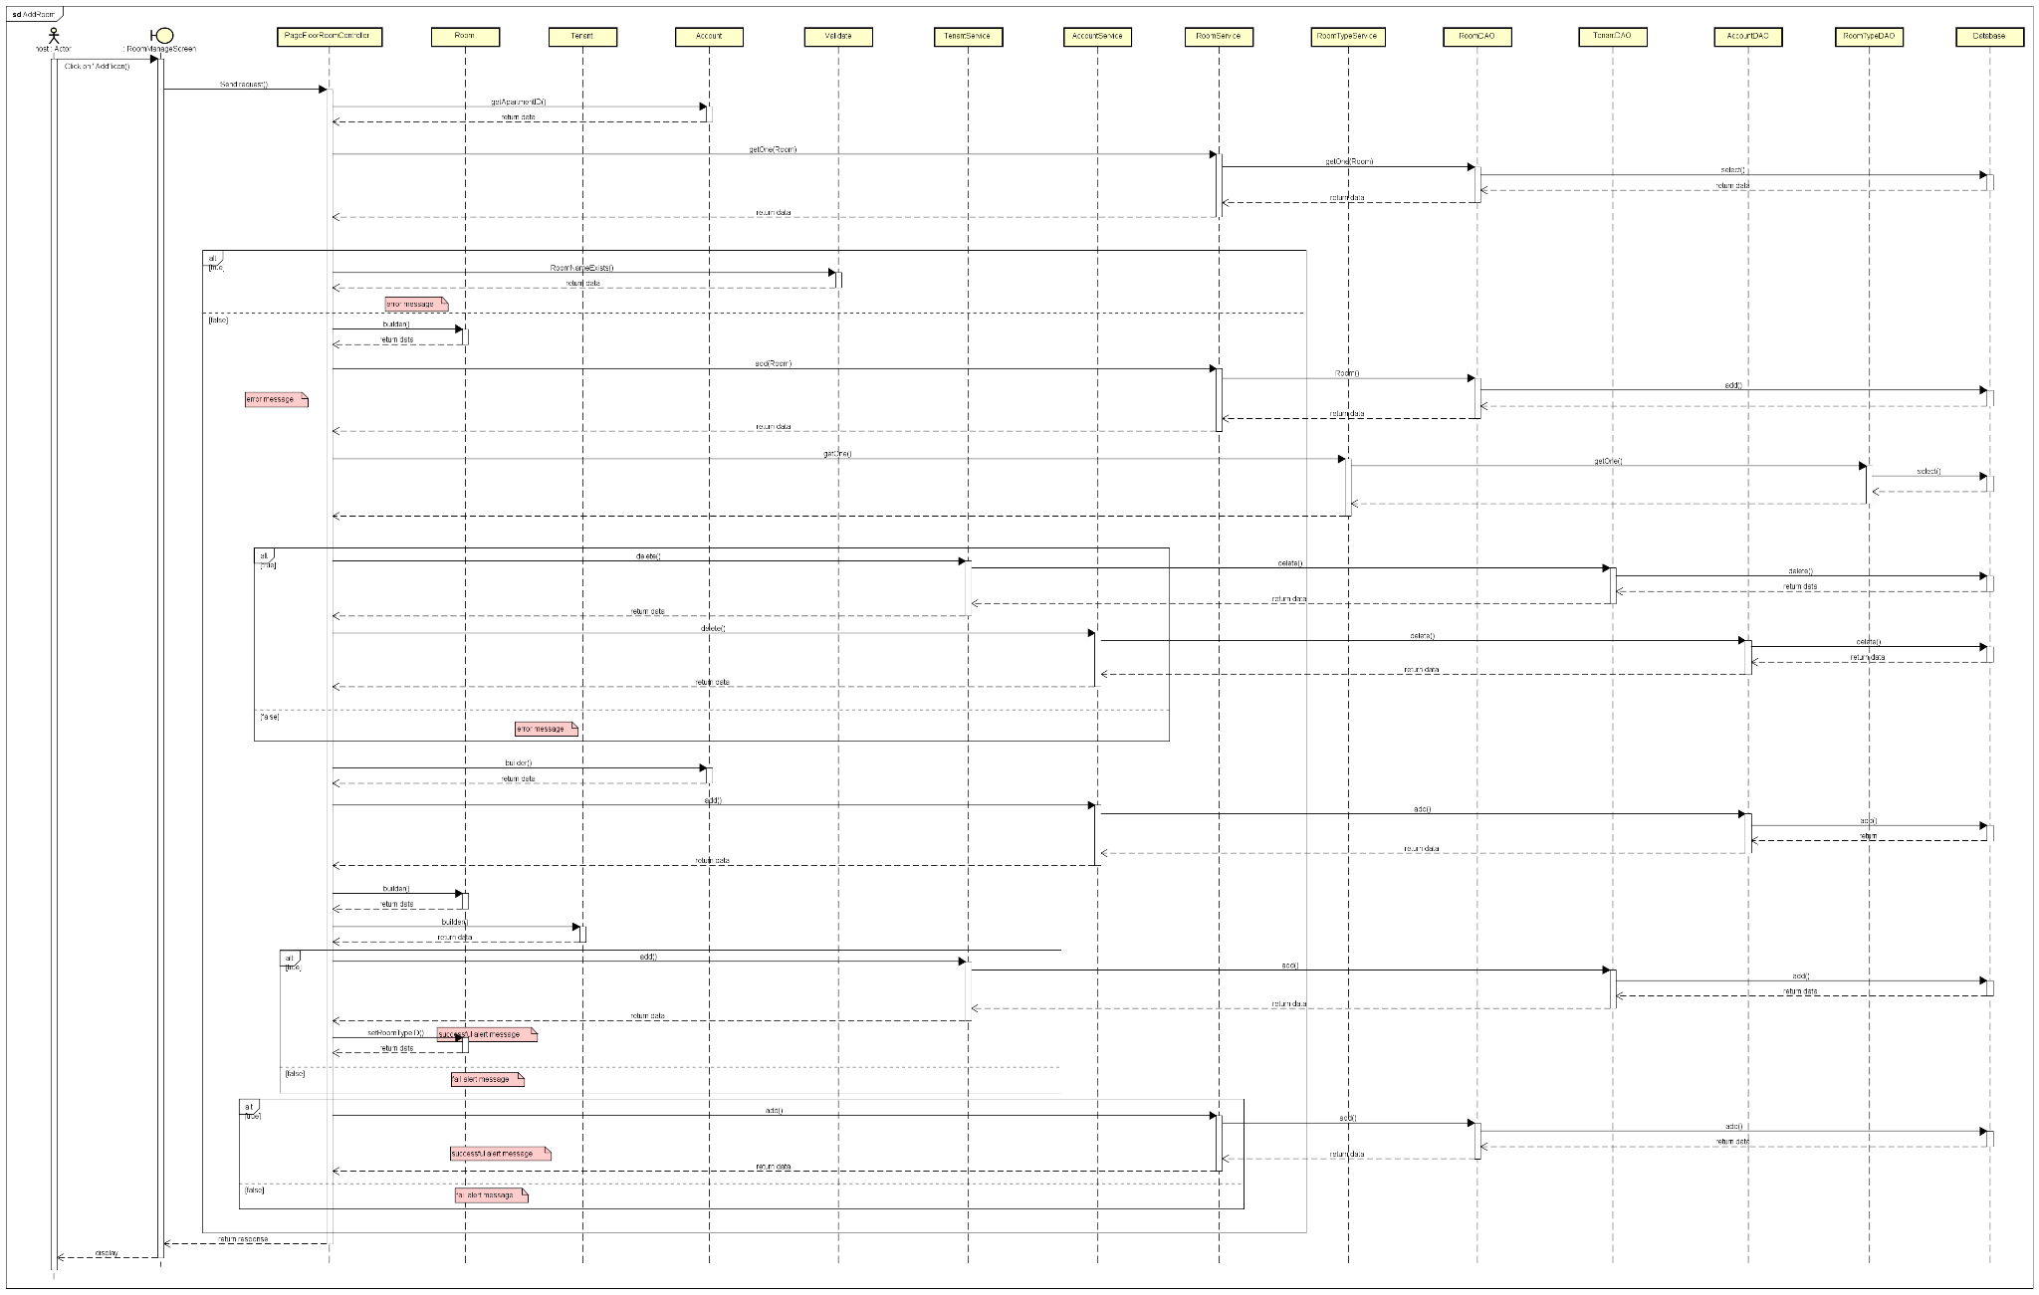

#### Function: Edit Room

#### 

#### Function: Delete Room

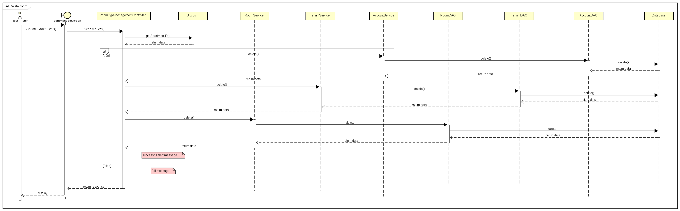

#### Function: Edit Floor

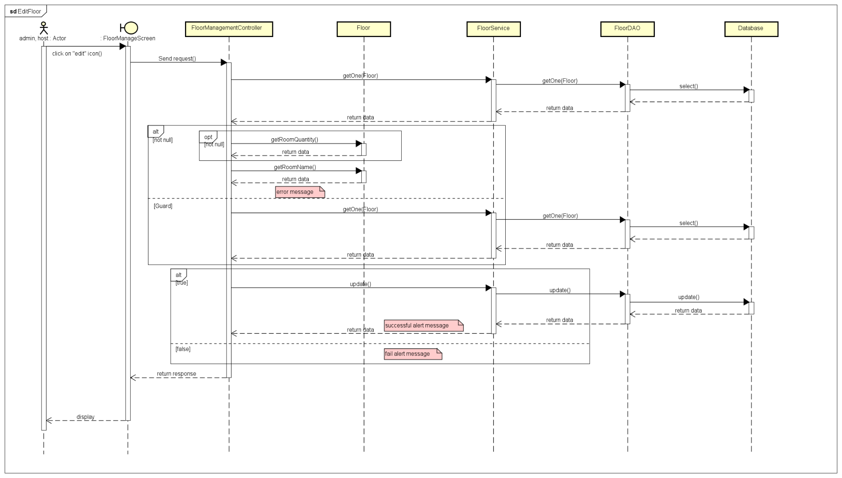

#### Function: Delete Floor

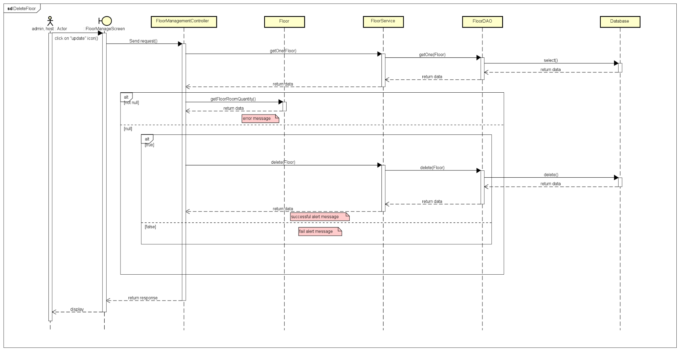

#### Function: Edit RoomType

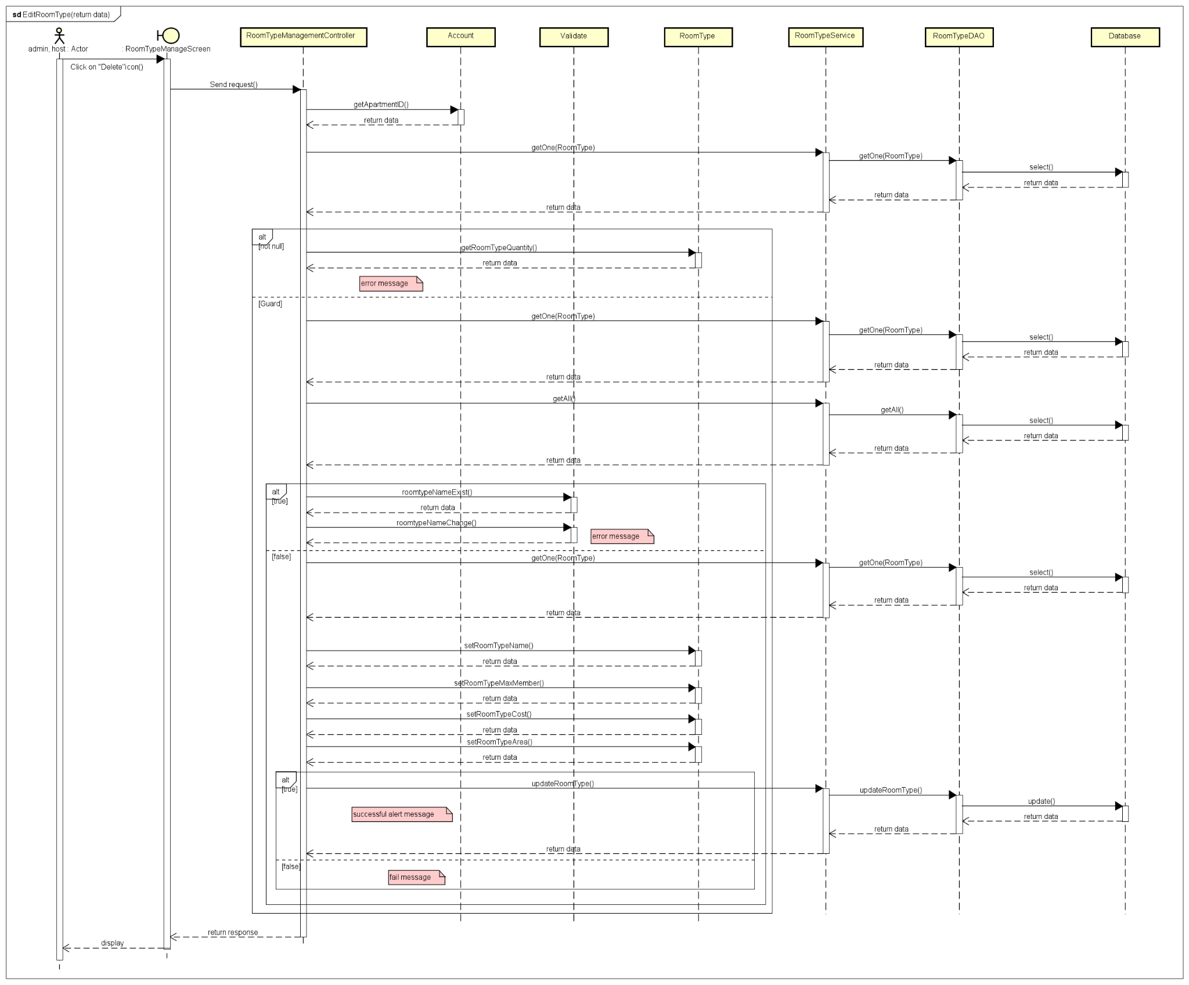

#### Function: Delete RoomType

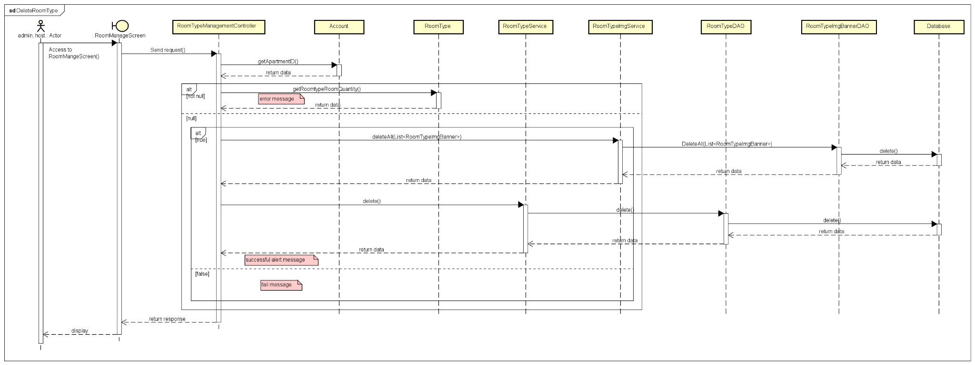

#### Function: View RoomType

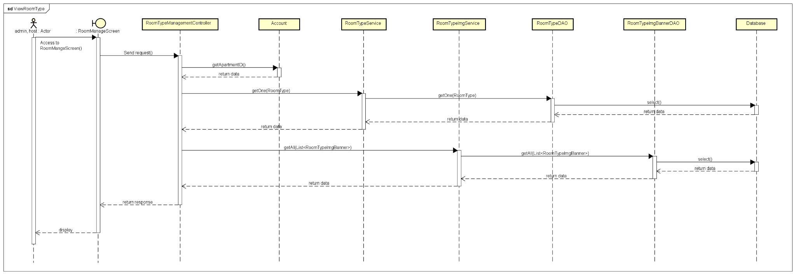

#### Function: View Tenant

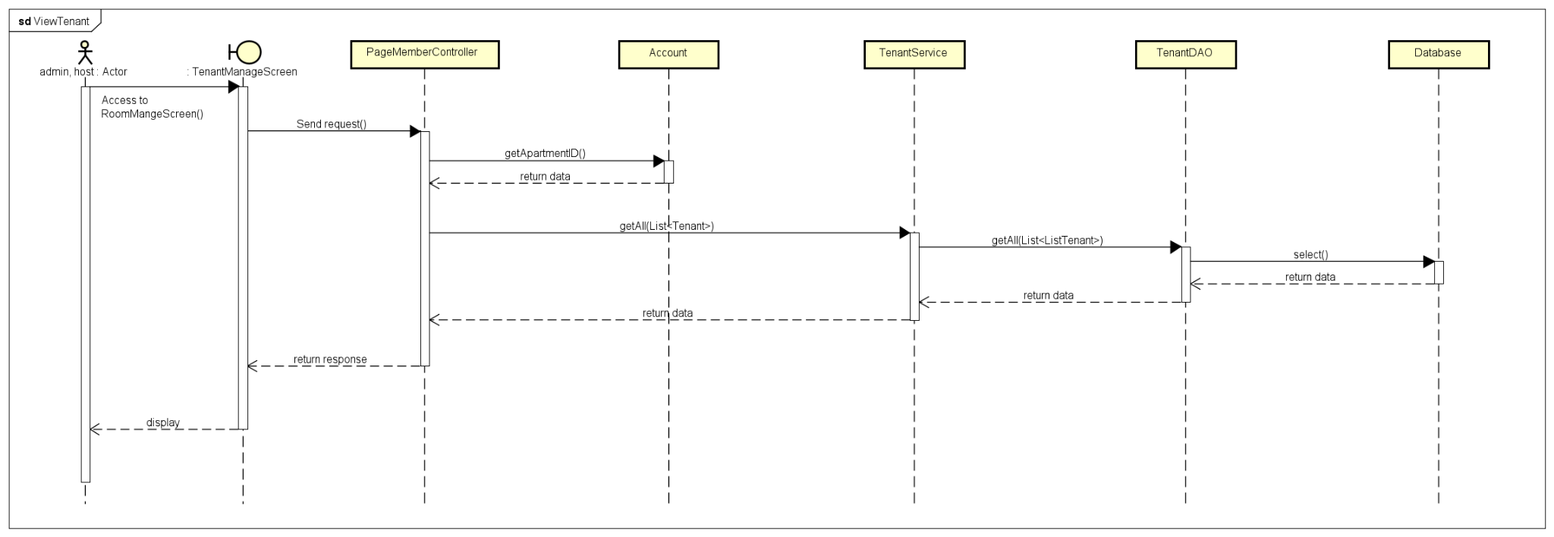

#### 

#### Function: Add Tenant

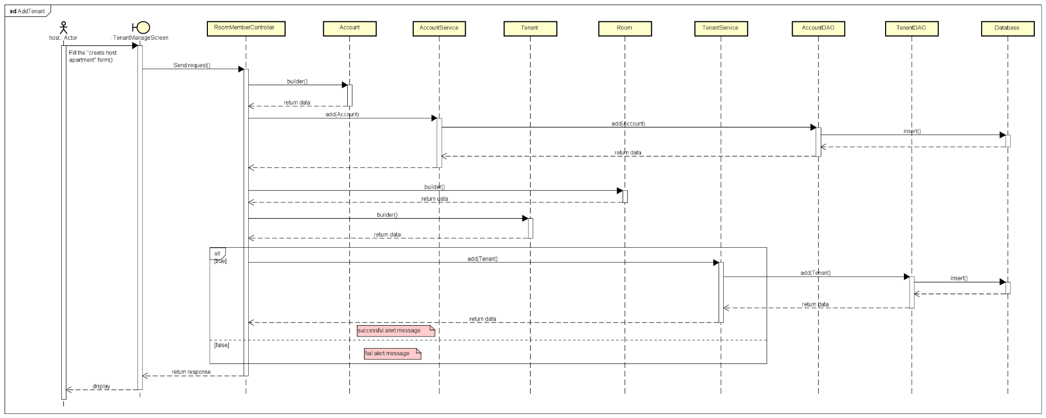

#### Function: Update Tenant

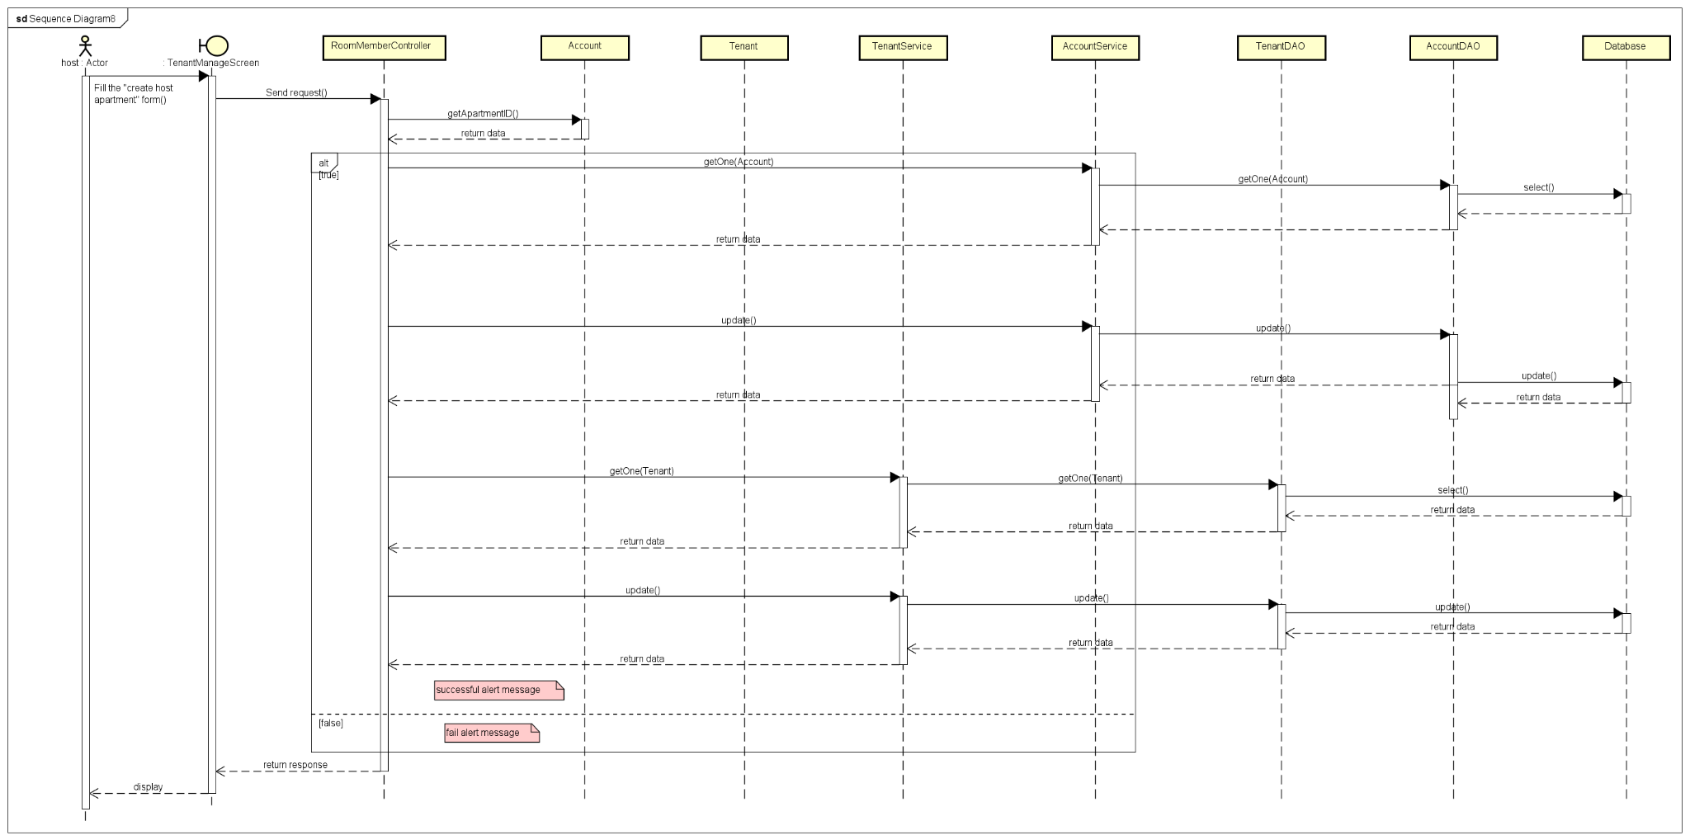

#### Function: Add Vehicle

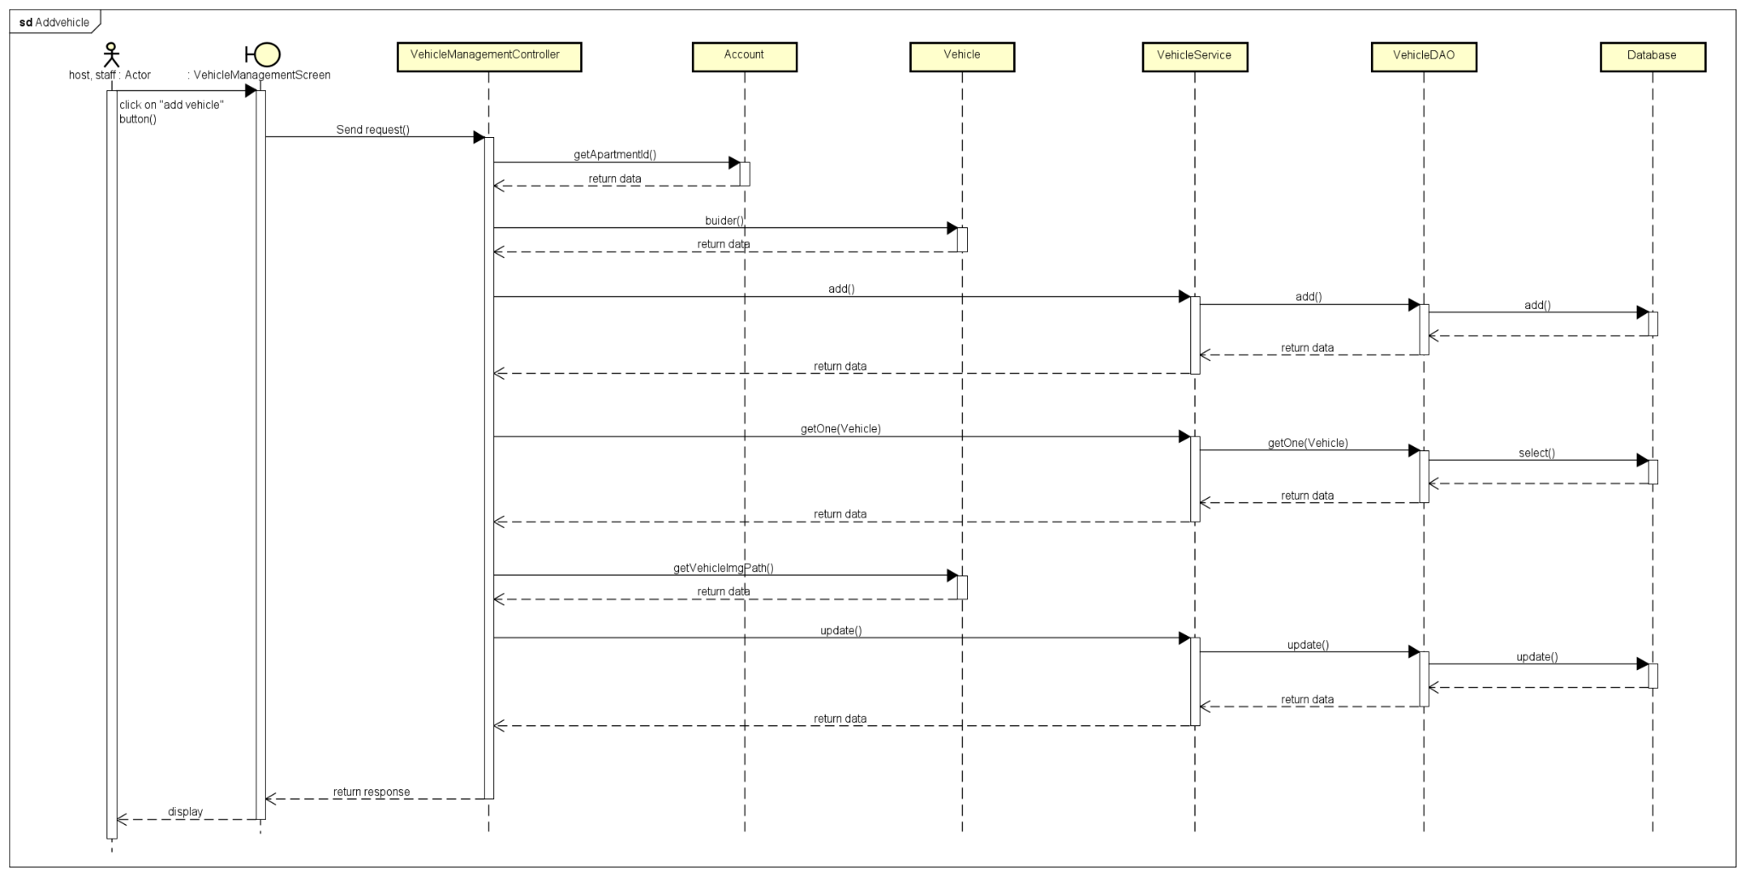

#### Function: Delete Vehicle

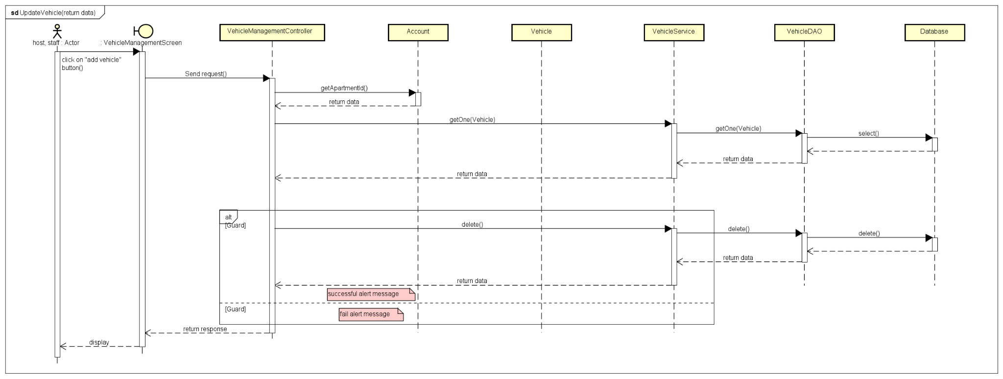

### d. Database Queries

***- Add Room function queries:***

*String sql = "INSERT INTO room(room_name, roomtype_id, floor_id, apartment_id , find_roommate, room_status_id)"*

*+ " VALUES(?, ?, ?, ? , ? , ?)";*

*-* ***Edit Room function queries:***

*"UPDATE room Set room_name = ?,roomtype_id = ?, floor_id = ?, apartment_id = ?, room_status_id = ?, find_roommate = ? WHERE room_id = ?";*

*-* ***Delete Room function queries:***

***“****DELETE FROM room Where room_id = ? AND floor_id = ?"*

*-* ***Edit Floor***

*“UPDATE floor Set floor_name = ?, floor_room_quantity = ? WHERE floor_id = ?";”*

***- Delete Floor***

***“****DELETE FROM floor Where floor_id = ? AND apartment_id = ?”*

***- Edit RoomType***

*"UPDATE roomtype Set roomtype_name = ?, roomtype_max_member = ?, roomtype_cost = ?, roomtype_area = ?, roomtype_room_quantity = ? WHERE roomtype_id = ?"*

***- Delete RoomType***

*"DELETE FROM roomtype Where roomtype_id = ? AND apartment_id = ?"*

***- View RoomType***

*"SELECT * FROM roomtype WHERE roomtype_id = ? AND apartment_id = ?"*

***- View Tenant***

***"****with te as(\n"*

*+ "SELECT t.tenant_id, "*

*+ "t.account_id, "*

*+ "t.room_id, "*

*+ "t.tenant_citizen_identification, "*

*+ "t.tenant_name, "*

*+ "t.tenant_dob, "*

*+ "t.tenant_phone_number, "*

*+ "t.tenant_parent_phone, "*

*+ "t.tenant_countryside, "*

*+ "a.apartment_id,"*

*+ "a.account_username,"*

*+ "a.account_password,"*

*+ "a.account_accessible,"*

*+ "a.role_id\n"*

*+ "FROM apamandb.tenant t Join apamandb.account a ON t.account_id = a.account_id \n"*

*+ "Where a.apartment_id = ? AND a.account_accessible = true) \n"*

*+ "\n"*

*+ "select te.* , r.room_name\n"*

*+ "FROM te JOIN apamandb.room r on te.room_id = r.room_id"*

***- Update Tenant***

*"UPDATE tenant SET\n"*

*+ "tenant_citizen_identification = ?, "*

*+ "tenant_name = ?, "*

*+ "tenant_dob = ?, "*

*+ "tenant_phone_number = ?, "*

*+ "tenant_parent_phone = ?, "*

*+ "tenant_countryside = ?"*

*+ "WHERE tenant_id = ?"*

***- Add Vehicle***

*"INSERT INTO vehicle(vehicle_type_id, vehicle_license_plate, vehicle_description,tenant_id,room_id,apartment_id,vehicle_img_path)"*

*+ " VALUES(?, ?, ?, ?, ?, ?, ?)"*

***- Update Vehicle***

*"UPDATE vehicle Set vehicle_type_id = ?, "*

*+ "vehicle_license_plate = ? , "*

*+ "vehicle_description = ? ,"*

*+ "tenant_id = ? ,"*

*+ "room_id = ? ,"*

*+ "apartment_id = ?,"*

*+ "vehicle_img_path = ?"*

*+ "WHERE vehicle_id = ?"*

### 

## 6. Feature 6: Manage Payment

### a. Class Diagram

### b. Class Specifications

PaymentController

| No | Method | Description |
| --- | --- | --- |
| 1 | doGet | displayed last month b |
| 2 | doPost | update and delete tenant in room |

GetElectricWaterControllerController

| No | Method | Description |
| --- | --- | --- |
| 1 | doGet | Display last updated payment |
| 2 | doPost |  |

confirmPaymentControllerController

| No | Method | Description |
| --- | --- | --- |
| 1 | doGet | View room type detail by apartmentID and roomtypeID |
| 2 | doPost | Update and Delete room type of apartment |

#### 

### c. Sequence Diagram(s)

### Update Payment

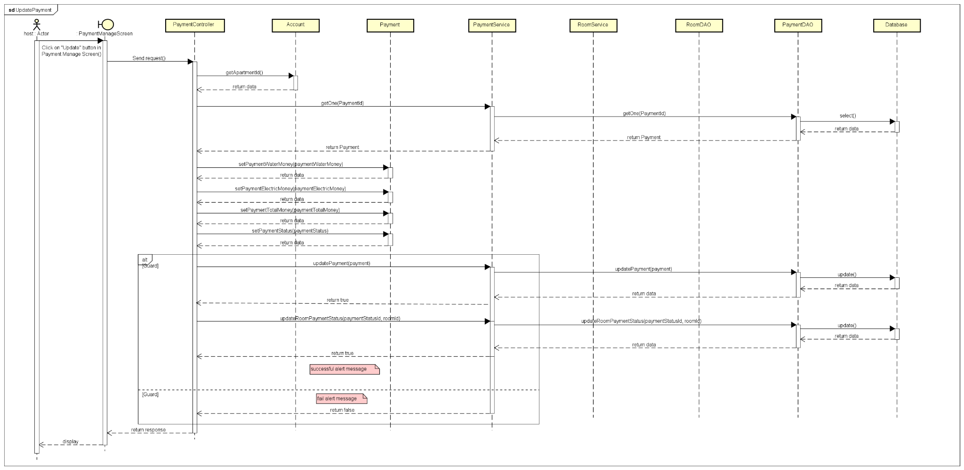

### 

### Add Payment

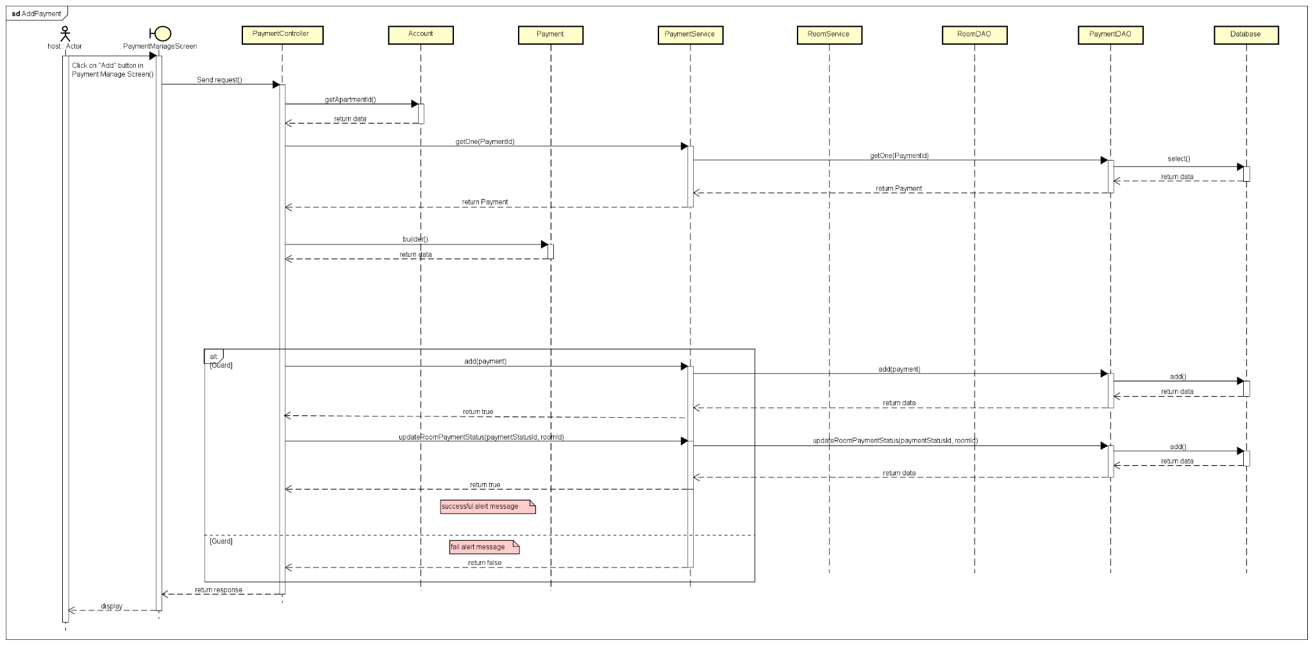

### View Payment

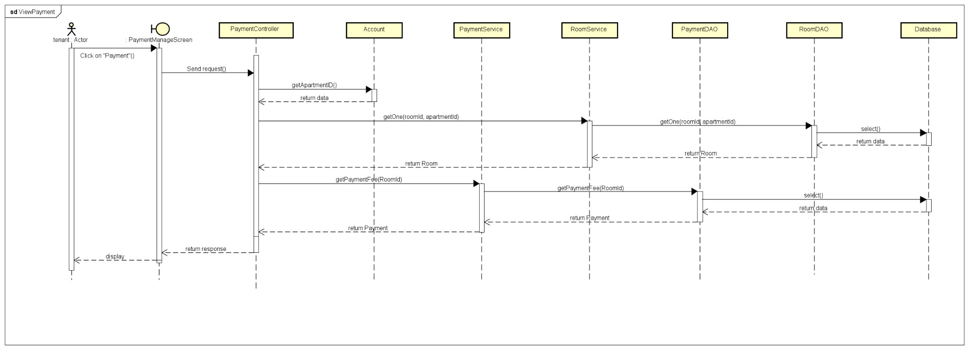

### d. Database Queries

***- Add Payment function queries:***

*"INSERT INTO payment(room_id, payment_room_unit_fee, "*

*+ "payment_water_index_pre, payment_electric_index_pre, payment_day_update_pre, "*

*+ "payment_water_index_cur, payment_electric_index_cur, payment_day_update_cur, "*

*+ "payment_water_unit_fee, payment_water_money,"*

*+ "payment_electric_unit_fee, payment_electric_money,"*

*+ "payment_car_quantity, payment_car_unit_fee, payment_car_money,"*

*+ "payment_motor_quantity, payment_motor_unit_fee, payment_motor_money,"*

*+ "payment_bike_quantity, payment_bike_unit_fee, payment_bike_money,"*

*+ "payment_total_money,"*

*+ "payment_status_id)"*

*+ " VALUES(?, ?, ?, ?, ?, ?, ?, ?, ?, ?, ?,?, ?, ?, ?, ?, ?, ?, ?, ?, ?, ?,?)"*

*"UPDATE room Set room_payment_status_id = ? WHERE room_id = ?"*

*-* ***Edit Payment function queries:***

*"UPDATE payment Set payment_water_money = ?, payment_electric_money = ? , payment_total_money = ?, payment_status_id = ? WHERE payment_id = ?"*

*"UPDATE room Set room_payment_status_id = ? WHERE room_id = ?"*

* ***View Payment function queries:***